**BA-706 (001)**

**Applied Analytic Modelling**

**SAS Final Project**

**Predictive Modelling on student performance**

**December 16, 2023**

**Course Professor: David Parent**

**Campus: Progress**

|  |  |
| --- | --- |
| Done by: | |
| * Alester Joshua D Costa | 301321745 |
| * Devansh Soni | 301239463 |
| * Khawja Nayeem Ather | 301187396 |
| * Miguel Polanco Sanchez | 301299027 |

**Table of Contents**

I. Introduction 4

II. Data Exploration 5

III. Decision Tree 10

i. Maximal Decision Tree 10

ii. Misclassification Decision Tree 11

iii. Average Square Error (ASE) Decision Tree 12

iv. Analysis and Interpretation of Decision Tree 13

IV. Impute 14

V. Cap and Floor 15

VI. Transform 16

VII. Recode Dummies 17

VIII. Regression 18

i. Full Regression 18

ii. Forward Regression 19

iii. Backward Regression 21

iv. Stepwise Regression 23

v. Analysis and Interpretation of Regression 24

IX. Neural Network 26

i. Impute Neural Network 26

ii. Cap and Floor Neural Network 27

iii. Transform Neural Network 28

iv. Stepwise Regression Neural Network 29

v. Forward Regression Neural Network 30

vi. Backward Regression Neural Network 31

vii. Full Regression Neural Network 32

viii. 1H Forward Regression Neural Network 34

ix. 2H Forward Regression Neural Network 35

x. 4H Forward Regression Neural Network 36

xi. 5H Forward Regression Neural Network 37

xii. 6H Forward Regression Neural Network 38

xiii. 7H Forward Regression Neural Network 39

xiv. 8H Forward Regression Network 40

xv. Analysis of Neural Network 40

X. Model Comparison 42

i. Analysis of model comparison 43

a. Interpretation of Backward Regression Model 43

XI. Conclusion and Recommendations 45

XII. References 46

# Introduction

In any educational setting, academic performance refers to the scale on which students have obtained their short-term or long-term educational objectives (Tadese, 2022, p. 2). There may be numerous determinants that could affect the academic performance of students; these components comprise of learning capabilities, financial circumstances, attitudes, family and more (Abu Bakar, 2023, p. 1498). According to Regier (2011), students are more likely to make the transition into adulthood and attain professional and lucrative success if they excel in their academics at school.

The main purpose of this report is to understand the student’s academic performance in two secondary schools of Portugal, namely Gabriel Pereira and Mousinho Da Silveria, through building predictive models on SAS Enterprise Miner. By utilizing predictive models such as decision trees, regressions, and neural networks, an analysis is carried out to predict if these students achieve an above-average grade in their final period of exams in the Portuguese subject. This report's main assessment measure utilized to compare the best predictive model is the **Receiver Operating Characteristic (ROC) index**. Additionally, the Average Squared Error (ASE) is also used to aid in the assessment. The data present within the chosen dataset of student performance in the Portuguese subjects has been collected through school reports and questionnaires, and the numerous variables present in the student performance dataset comprise of student grades marked with the Portuguese grading system, demographics, social and school-affiliated characteristics (Chauhan, 2022).

# Data Exploration

To carry out the process of predicting whether secondary school students would score an above-average grade in their final period grade of the Portuguese subject, a total of 35 variables are present in the student performance dataset. Out of these 35 variables, the *G3_AboveAverage* variable represents a target variable where its binary values are modeled and predicted by other 29 variables. Furthermore, there are 4 variables that have been rejected from the predictive modeling process because they have a very strong correlation with the target variable. In essence, the variables of *G1*, *G2,* and *G3* have been rejected since each variable would not have been helpful to develop a predictive model with these variables present. Additionally, the *failures* variable is rejected because it only consists of a range of numbers from 0 to 4 representing the count of prior student failures in their academics. To mitigate this concern, *the failures_past* has been created with a binary measurement level indicating whether students have had previous failures. Figure 1 highlights the necessary amendments made to the dataset variables of student performance in the Portuguese subject on SAS Enterprise Miner. The following table describes each of the variables present within the dataset of student performance in the Portuguese subject.

| **Variable** | **Model Role** | **Measurement Level** | **Description** |
| --- | --- | --- | --- |
| *absences* | Input | Interval | Number of student’s absences from school  (From 0 to 93) |
| *activities* | Input | Binary | Participation of student in extra-curricular activities  (Either yes or no) |
| *address* | Input | Nominal | Student’s home address type  (Either ‘U’: Urban or ‘R’: Rural) |
| *age* | Input | Interval | Student’s age  (From 15 to 22) |
| *Dalc* | Input | Interval | Workday consumption of alcohol  (From 1: very low to 5: very high) |
| *failures* | Rejected | Interval | Number of previous failures by students at class  (From 0 to 4) |
| *failures_past* | Input | Nominal | Previous failures encountered by students based on the *failures* variable  (Either yes or no) |
| *famrel* | Input | Interval | Quality of student’s relationship with their family  (From 1: very bad to 5: excellent |
| *famsize* | Input | Nominal | Size of student’s family  (Either ‘LE3’: Less than or equal to 3 or ‘GT3’: Greater than 3) |
| *famsup* | Input | Binary | Family educational support  (Either yes or no) |
| *Fedu* | Input | Interval | Educational level of student’s father  (Either 0 : None or  1 : Primary education,  2 : 5th to 9th,  3 : Secondary education or  4 : Higher education) |
| *Fjob* | Input | Nominal | Job of student’s father  (Either 'teacher', 'health' care related, civil 'services' (e.g. administrative or police), 'at_home' or 'other') |
| *freetime* | Input | Interval | Free time after school  (From 1 - very low to 5 - very high) |
| *G1* | Rejected | Interval | First period grade  (From 0 to 20) |
| *G2* | Rejected | Interval | Second period grade  (From 0 to 20) |
| *G3* | Rejected | Interval | Third period grade  (From 0 to 20) |
| *G3_AboveAverage* | Target | Binary | Above average grade attained by students based on the *G3* variable  (Either yes or no) |
| *goout* | Input | Interval | Going out with friends  (From 1: very low to 5: very high) |
| *guardian* | Input | Nominal | Student’s guardian  (Either ‘mother’, ‘father’ or ‘other’) |
| *health* | Input | Interval | Current health status  (From 1: very bad to 5: very good) |
| *ID* | ID | Nominal | Unique identifier for each student |
| *internet* | Input | Binary | Internet access available for students at home  (Either yes or no) |
| *Medu* | Input | Interval | Educational level of student’s mother  (Either 0: none,  1: primary education (4th Grade),  2: (5th to 9th Grade),  3: Secondary Education or  4: higher Education) |
| *Mjob* | Input | Nominal | Job of student’s mother  (Either ‘teacher’, ‘health’ care related, civil ‘services’, ‘at_home’ or ‘other’) |
| *nurserv* | Input | Binary | Nursery attended by student  (Either yes or no) |
| *paid* | Input | Binary | Extra paid classes taken for the Portuguese subject  (Either yes or no) |
| *Pstatus* | Input | Nominal | Cohabitation status of student’s parents  (Either ‘T’: living Together or  ‘A’: Apart) |
| *reason* | Input | Nominal | Reason for selecting the school  (Either close to ‘home’, school ‘reputation’, ‘course’ preference or ‘other’) |
| *romantic* | Input | Binary | Student in a romantic relationship (Either yes or no) |
| *school* | Input | Nominal | Student’s school  (Either ‘GP’: Gabriel Pereira or  ‘MS’: Mousinho da Silveira) |
| *schoolsup* | Input | Binary | Extra educational support  (Either yes or no) |
| *sex* | Input | Nominal | Student’s gender  (Either ‘F’: Female, or ‘M’: Male) |
| *studytime* | Input | Interval | Student’s weekly study time  (1: Less than 2 hours,  2: Between 2 to 5 hours,  3: Between 5 to 10 hours, or  4: More than 10 hours) |
| *traveltime* | Input | Interval | Home to school travel time  (1: Less than 15 minutes,  2: Between 15 to 30 minutes,  3: Between 30 minutes to 1 hour, or  4: More than 1 hour) |
| *Walc* | Input | Interval | Weekend consumption of alcohol  (1: very low to 5: very high) |

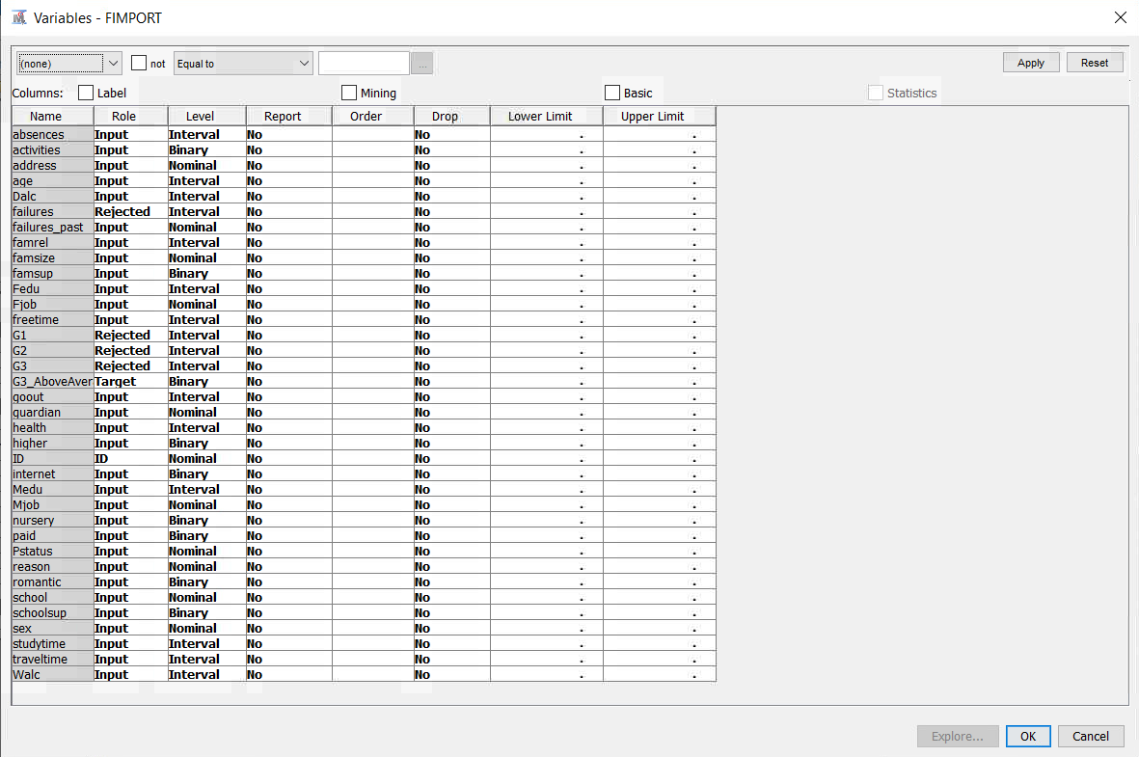

# Decision Tree

After carrying out the process of choosing the Portuguese schools’ dataset and configuring the relevant roles and levels of each variable, three decision tree models have been developed on SAS Enterprise Miner, comprising of the maximal tree, misclassification tree, and average square error tree. In each decision tree that has been developed, the thickest black line represents the optimal path and the dark blue leaves depict the most optimal leaves.

## Maximal Decision Tree

The first decision tree that has been built for predicting whether students score an above-average grade in their final period exam (G3) in the Portuguese subject is a maximal tree. To create a maximal tree model on SAS Enterprise Miner, a decision tree node has been created from the model tab and is linked from the data partition node to the developed maximal tree model. Furthermore, the properties of the maximal tree node are modified to alter the method and assessment measure as largest and decision, respectively. Upon running the built maximal tree node, it has been found that the average square error of the model for predicting the average grade of students stands at **0.194757**.

## Misclassification Decision Tree

A misclassification tree is a type of decision tree specifically designed for categorical target variables. It uses the misclassification rate as the splitting criterion to build the tree, aiming to minimize the overall misclassification of observation.

To create a misclassification tree model on SAS Enterprise Miner, a decision tree node has been created from the model tab and is linked from the data partition node to the developed misclassification tree model. Furthermore, the properties of the misclassification tree node are modified to alter the method and assessment measure as ‘Assessment’ and 'Misclassification’, respectively. The rest of the properties have been kept as default. Upon running the built misclassification tree node, it has been found that the average square error stands at **0.188776**.

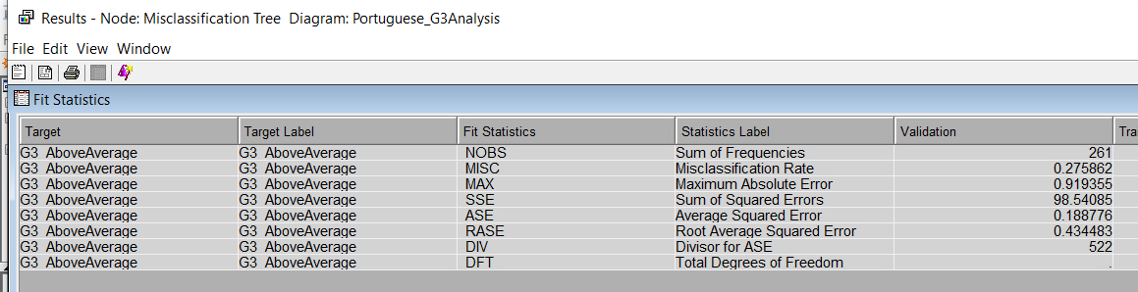

## Average Square Error (ASE) Decision Tree

The third and final decision tree of ASE tree has been developed. Similar to the previously built maximal decision tree and misclassification tree within SAS Enterprise Miner, a decision tree node has been developed from the model tab and is connected from the data partition node to the created ASE tree. While the method of the ASE tree has been changed to ‘Assessment’, the ASE tree’s other property of the assessment measure has been updated to ‘Average Squared Error’. After running the created ASE tree node, the ASE of the model is **0.185933.**

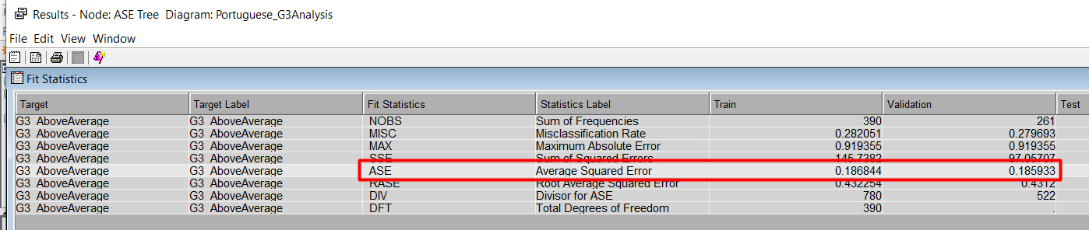

## Analysis and Interpretation of Decision Tree

Based on the generated ASE figures that have been generated for each created decision tree model, consisting of the maximal tree, misclassification tree and ASE tree, the most optimal decision tree is the ASE tree. By having the lowest ASE figure of **0.185933** among all the decision tree models, the ASE tree represents the best model in comparison to the misclassification tree and maximal tree, with ASE figures of **0.188776** and **0.194757**, respectively.

As part of the developed ASE decision tree model, the root node that has been generated for identifying the likelihood of students scoring or not scoring an above average grade, i.e. *G3*, in the Portuguese subject is the previous failures encountered by students in their previous academic years, i.e. the *failures_past* variable. Out of the possible aspects, the most optimal path of the ASE tree highlights that students are more likely to achieve an above-average grade without having any past failures. If students have not had prior failures in their previous academic periods, there is a 61.88% probability that they would score an above-average grade in the final period of the Portuguese subject. In contrast, students who have encountered failures in their previous academic years have a 94.74% of not obtaining an above average grade in their final grade and represents the highest probability value among all leafs present in the ASE tree model.

The interior nodes of the ASE tree model indicates that there if a student is pursuing their current education at the school of Gabriel Pereira, i.e., the *GP* variable and have an inclination of seeking higher education, i.e. *higher*, upon the completion of their secondary education, there is a 69.48% and 72.11% probability, respectively, of obtaining an above average grade in their final period, i.e., *G3* of the Portuguese subject. On the contrary, another leaf node indicates that students pursuing their secondary education at the school of Mousinho da Silveira (MS) have a lesser probability of 44.93% with attaining an above average grade in their final period grade. Finally, another significant leaf of the model highlights that students who take fewer than 3.5 hours with travelling to campus, i.e., *traveltime*, have a 73.43% probability of achieving an above average grade in their final period of the Portuguese subject.

# Impute

Impute nodes are essential to account for missing records in a given dataset. Although the obtained dataset did not have any missing values, it is vital to utilize the impute node for the long-term use of the model in the event missing values are encountered in the future.

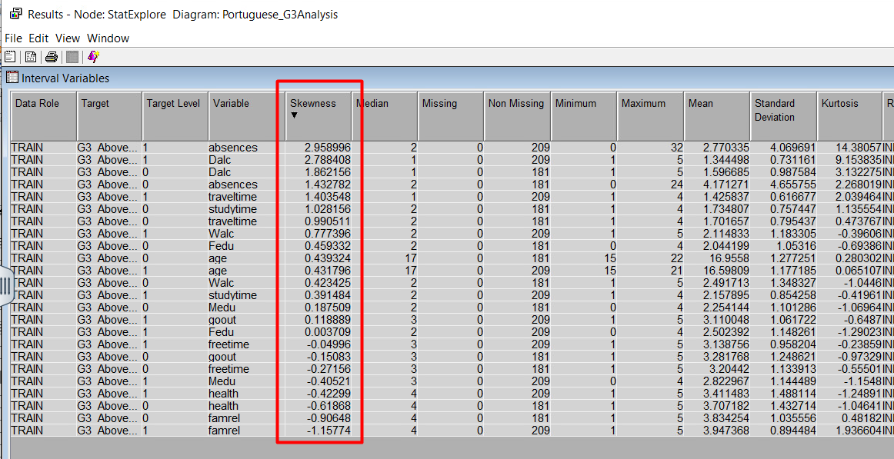The Impute node, which is connected with the Data Partition node, reflects that some variables have a high skewness level. The result has been obtained by connecting a StatExplorer node to the Impute node. The property changes made to this node from the default settings have the type changed to Unique and the Role to Input. With these changes, the skewness level of the variables has been identified and describe the variables that have a skewness level above 2; in this case, the variables are *absences* and *Dalc*.

# Cap and Floor

After the Impute node, a replacement node was run for the Cap and Floor. The properties of the replacement node have been kept to default and the affected variables comprise of *absences*, *traveltime*, *studytime* and *age*. The Cap and Floor node has assisted in minimizing skewness of the *absences* variable; previously, the skewness stood at 2.96 and then reduced to 1.68, which is an acceptable skewness for the model.

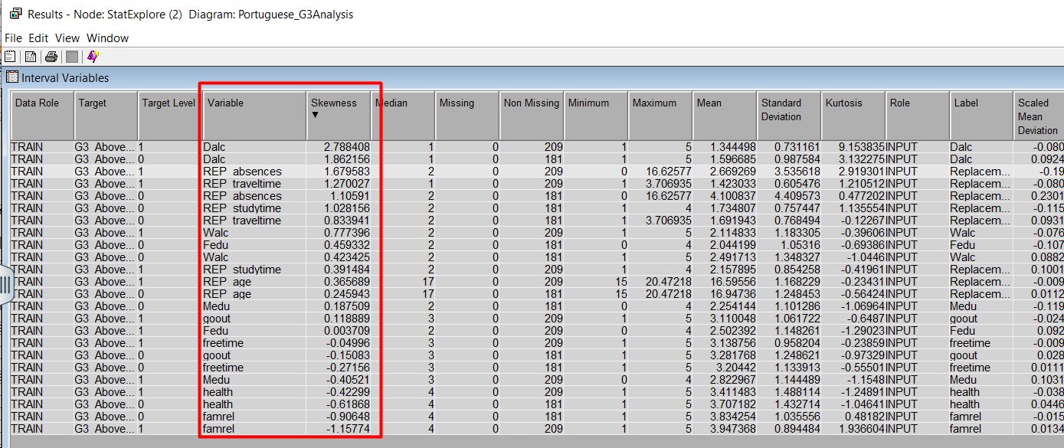On the other side, the *Dalc* variable has not been affected by the Cap and Floor and it continues to represent a skewness above 2. For the next step, it is important to create a Transform node to address the level of skewness for the *Dalc* variable.

# Transform

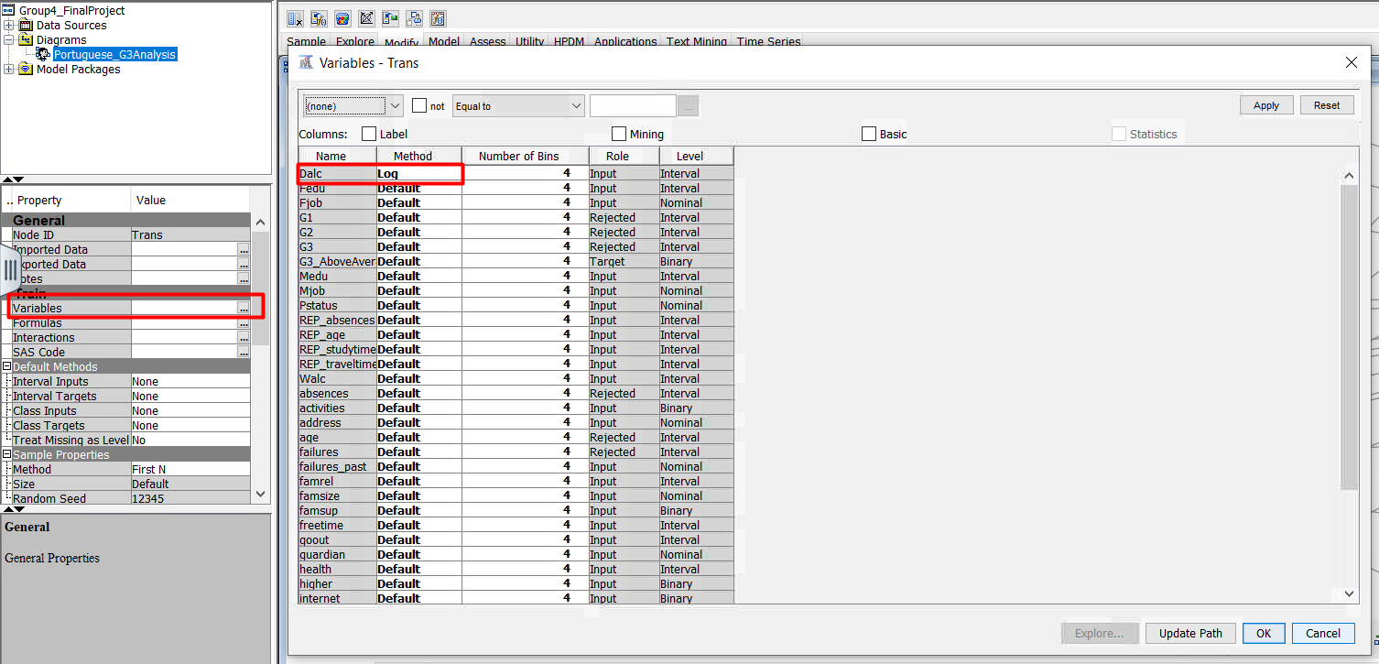Following the statistical guidelines, it was necessary to create a Transform node to address the level of skewness of one of the variables. To fix the level of skewness of the variable *Dalc*, in the properties of the Transform node, the variable method of the *Dalc* variable has been changed from default to Log. With this change, the values of the variable *Dalc* have been changed to Log form, reducing the skewness below 2 and down to 1.98. Since all the variables have their skewness minimized to less than 2, the next stage of developing regression models has been carried out.

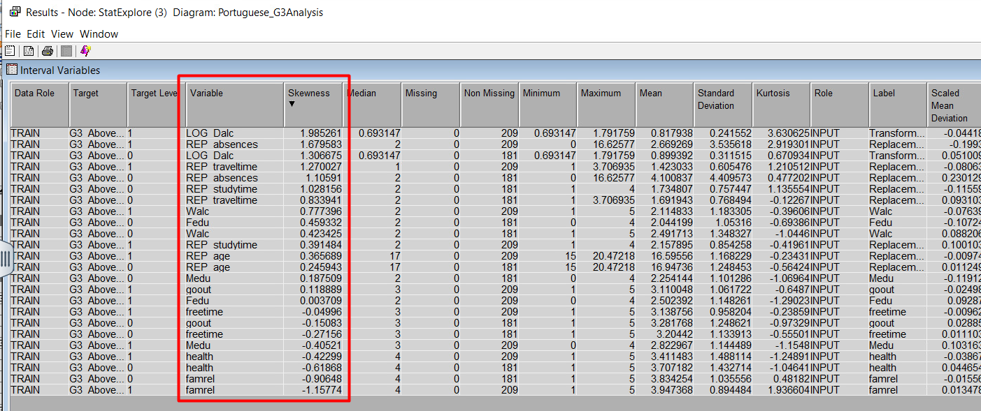

# Recode Dummies

To run the Recode Dummies, a Replacement node is needed to combine different categories such that the interpretation of the model is not impacted. However, in the context of this report, the Recode Dummies is not required considering all the variables in the dataset has different business meaning that can potentially result in varying business actions.

# Regression

The second type of predictive model that has been developed for understanding if students score an above-average grade in their final period grade of the Portuguese subject is regression. From the Portuguese student performance dataset, the four regression models that have been constructed comprise of full regression, forward regression, backward regression and stepwise regression.

## Full Regression

A Full Regression model helps in identifying which factors have a significant impact on the outcome and how they interact with each other, allowing for a comprehensive analysis of their relationships.

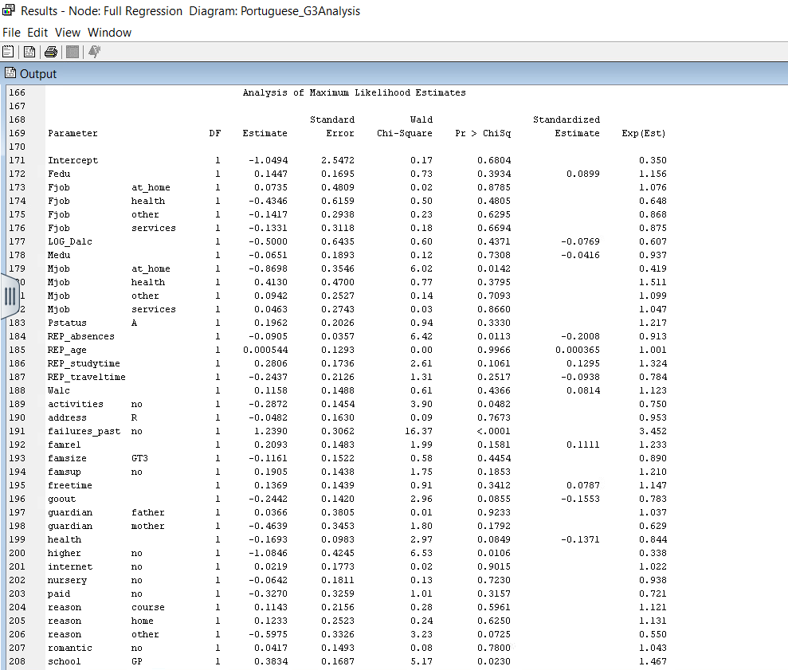To compute the full regression, the Full Regression node is connected to the Transform node. In the property section of Full Regression, Selection Model is selected as ‘None’ and Selection Criterion is changed to ‘Validation Error’. Upon running the Full Regression model, ASE result was **0.170415.** Figure 12 and 13 displays the ASE results and output.

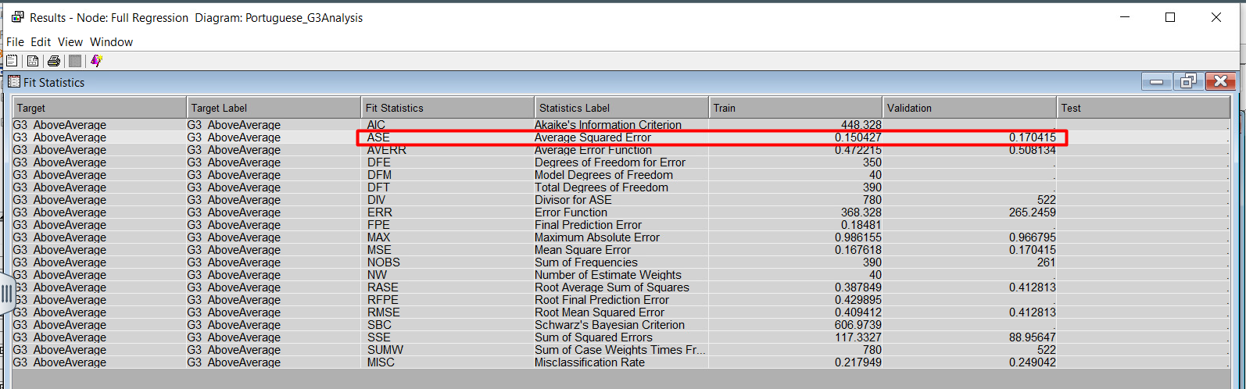

## Forward Regression

Forward regression in SAS Enterprise gradually adds predictor variables to a model, selecting the most impactful ones that enhance the model's predictive power until no further variables significantly improve its performance.

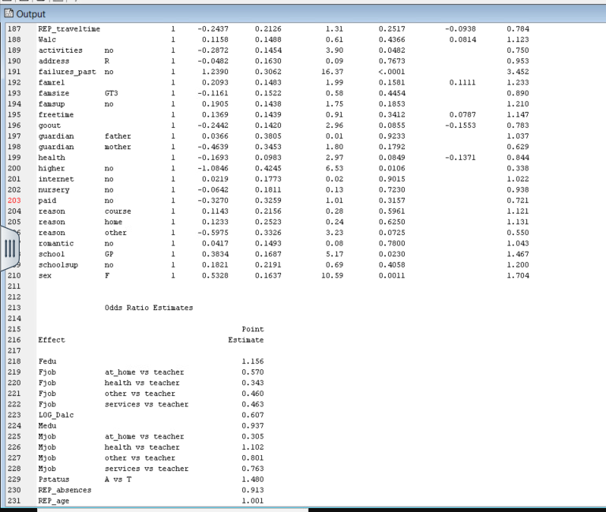As done with the previous model, Forward Regression node was connected to the Transform node and in the property section, Selection Model was selected as ‘Forward’ and Selection Criterion was changed to ‘Validation Error’. The ASE result of this model was **0.169618.** The illustrations below show the ASE results and output.

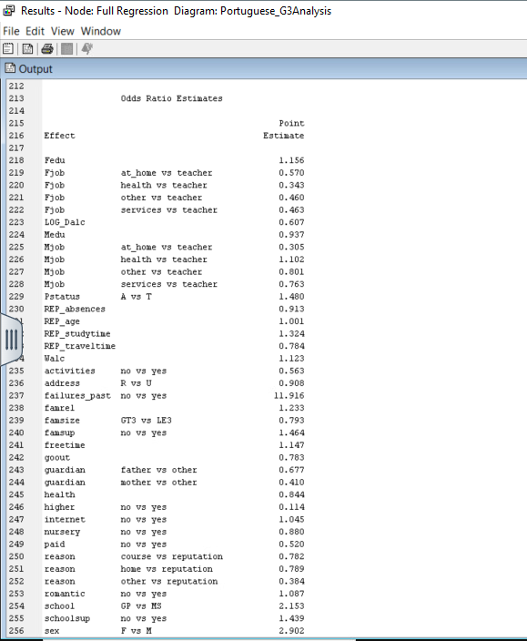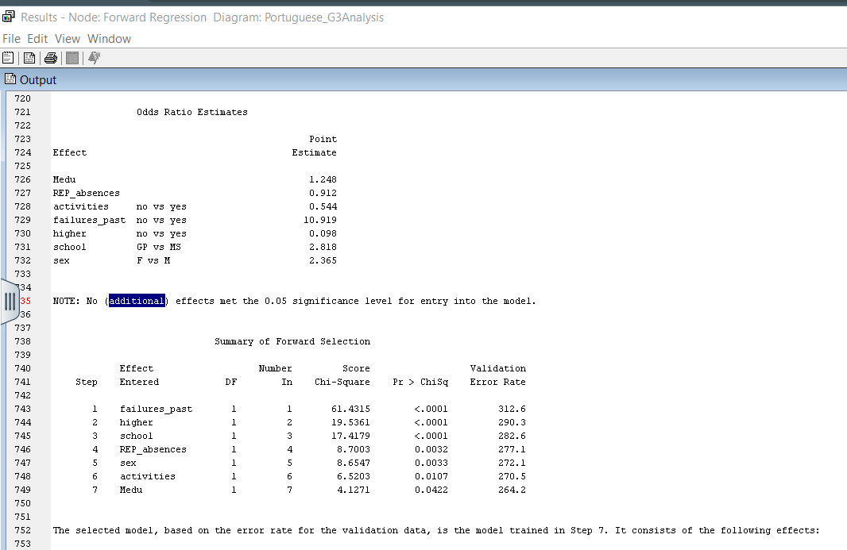

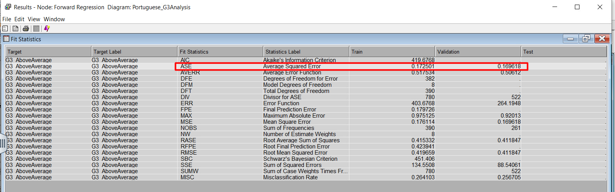

## Backward Regression

In SAS Enterprise Miner, backward regression begins with a model containing all predictors and eliminates the least impactful variables one by one until the model's predictive performance no longer significantly improves.

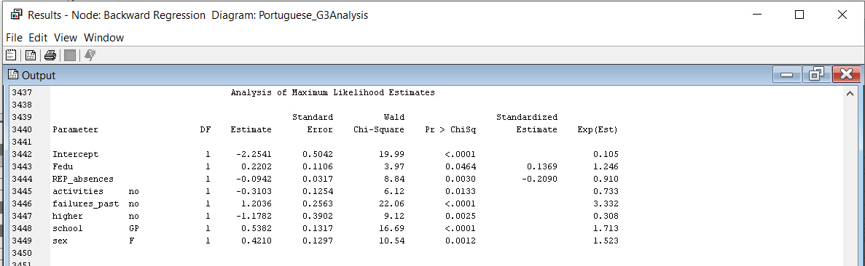Here, the Backward Regression node has been connected to the Transform node and Selection Model and Selection Criterion has been changed to ‘Backward’ and ‘Validation Error’, respectively. Upon running the model, ASE result was **0.166314.** The figures below highlight the results of the model.

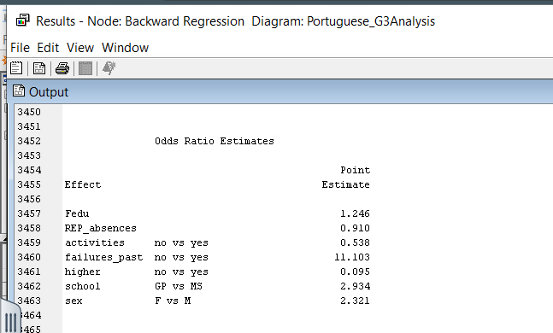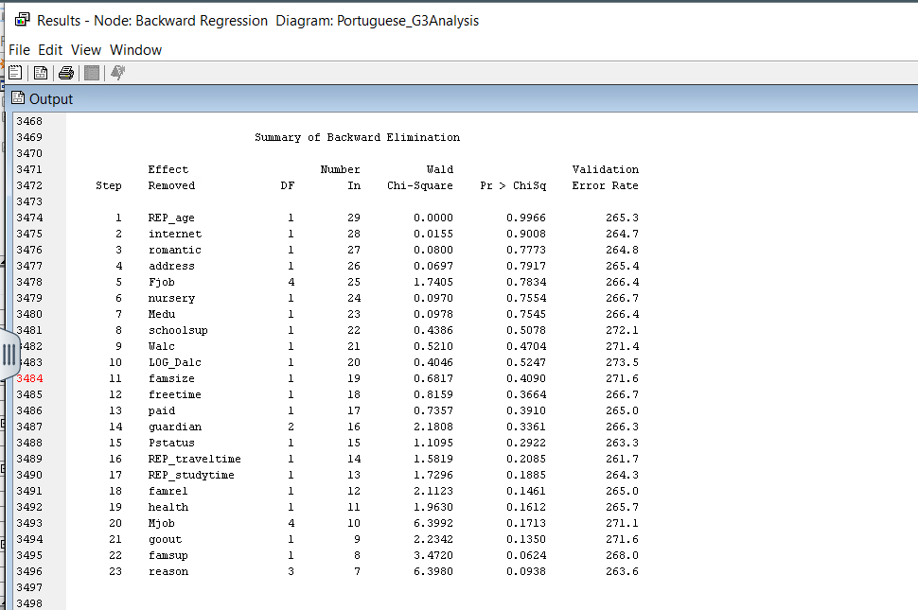

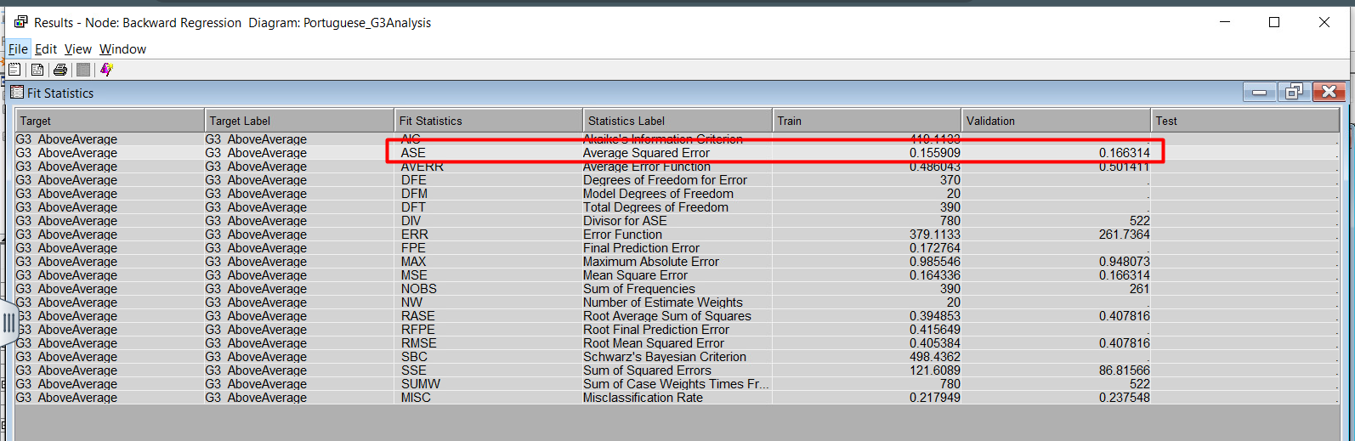

## Stepwise Regression

The final regression model that has been created is a Stepwise model, which is a method that automatically selects the most important variables for a model by adding or removing them based on their impact on improving the model's accuracy.

Under the properties, Selection Model has been selected as 'Stepwise’ and Selection Criterion has been changed to ‘Validation Error’. ASE value resulted in **0.169618.** The illustrations below display the results of the model.

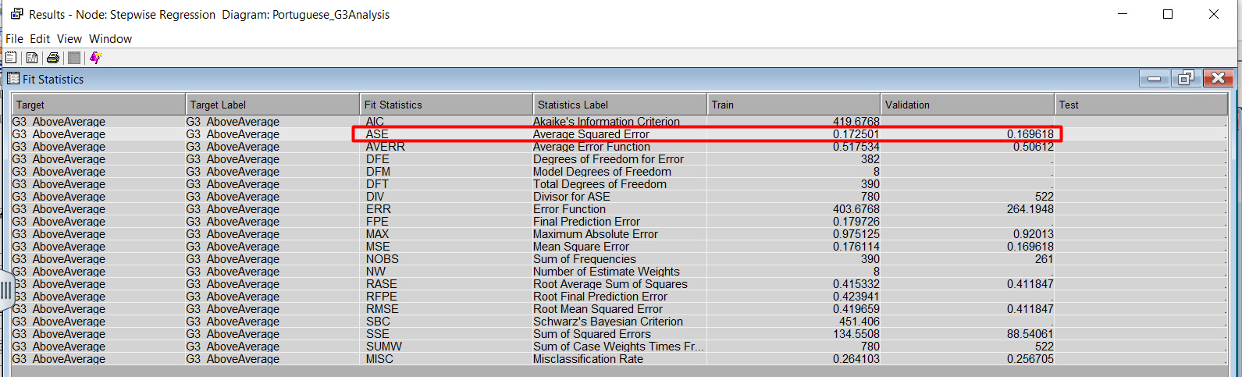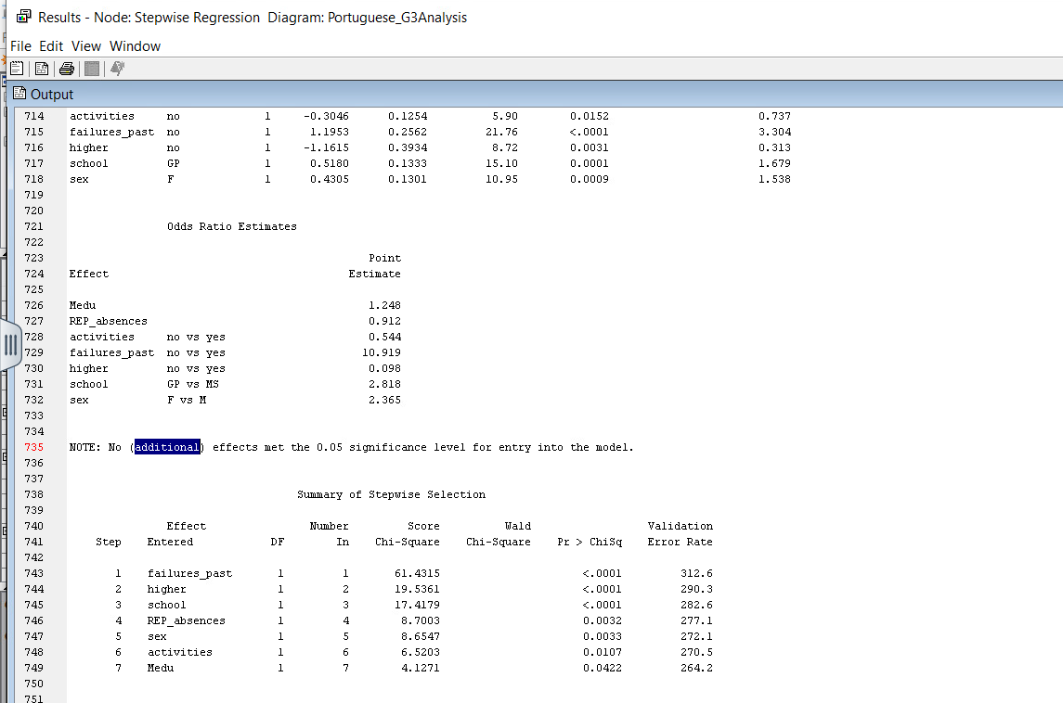

## Analysis and Interpretation of Regression

After analyzing the four regression models, the backward regression is selected as the most optimal model due to it having the lowest ASE score. While analyzing the output of the model, a notable observation is that the backward regression model did 23 steps while eliminating the variables with the higher Pr > ChiSq. After the completion of this process, the variables with the maximum likelihood of success were the ones with a Pr > ChiSq below 0.05. The variables with the lowest Pr > ChiSq and the highest Wald Chi-Square were, in order of importance, the following:

1. *failures_past* with the No result*,* a Wald Chi-Square of 22.06 and a Pr > ChiSq of <0.0001.
2. *school* with a GP result, a Wald Chi-Square of 16.69 and a Pr > ChiSq of <0.0001.
3. *sex* with a F result, a Wald Chi-Square of 10.54 and a Pr > ChiSq of 0.0012.
4. *higher* with the No result, a Wald Chi-Square of 9.12 and a Pr > ChiSq of 0.0025.
5. *REP_absence* with a Wald Chi-Square of 8.84 and a Pr > ChiSq of 0.0030.
6. *activities* with a No result, a Wald Chi-Square of 6.12 and a Pr > ChiSq of 0.0133.
7. *Fedu* with a Wald Chi-Square of 3.97 and a Pr > ChiSq of 0.0464.





As for the odds ratio the best variables for this model can be interpreted as follows in order of their impact on the target variable:

1. ***failures_past:***Students who have not failed in the past are 11.103 times more likely to score above-average grades in G3 than students who have failed in the past.
2. ***school*:** Students who go to GP school are 2.934 times more likely to score above-average grades in G3 than students who go to MS school.
3. ***sex*:** Students who are Female are 2.321 times more likely to score above-average grades in G3 than students who are Male.
4. ***higher:*** Students who do not want to pursue a higher education are 90.5% less likely to score above-average grades in G3 than students who want to pursue a higher education.
5. ***Rep_absence*:** For every unit increase in *Rep_absences*, there is a 9% decrease in the probability of scoring an above-average grade in G3. This indicates that as students' absences increase, the probability of scoring an above-average grade in G3 decreases.
6. ***activities*:** Students who do not perform any extracurricular activities are 46.2% less likely to score above-average grades in G3 than students who perform any extracurricular activities.
7. ***Fedu*:** For every unit increase in *Fedu*, there is a 24.6% increase in the probability of scoring an above-average grade in G3. This indicates that as the father’s education level increases, the probability of scoring an above-average grade in G3 for the student increases as well.

# Neural Network

The third and final type of predictive model that has been created for predicting whether students attain an above average grade in their final period of the Portuguese subject is neural network. For this report, 13 neural networks have been constructed to discover the optimal neural network model.

## Impute Neural Network

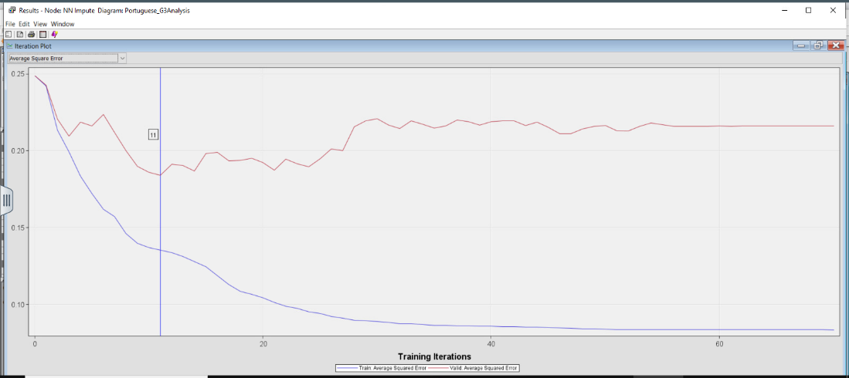The Impute Neural Network is a Neural Network node that is connected to the Impute node. This Neural Network shows the number of training iterations the model made and as the properties of the Neural Network are set to a maximum of 100, the Impute Neural Network converges and gets the optimal iterations at 11. This model has an Average Squared Error of **0.184225**. The illustrations below depict the results of the model.

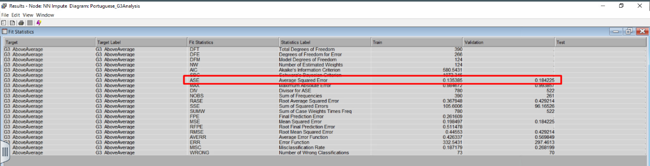

## Cap and Floor Neural Network

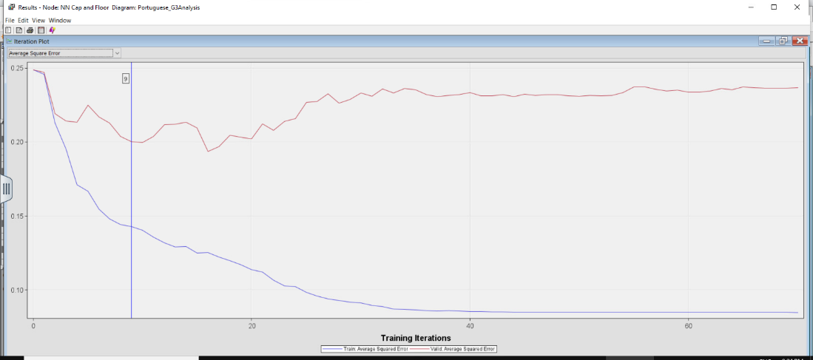The next Neural Network is the Cap and Floor Neural Network connected to the Cap and Floor node. This Neural Network shows the number of training iterations the model made and as the properties of the Neural Network are set to a maximum of 100, the Cap and Floor Neural Network converges and gets the optimal iterations at 9. This model has an Average Squared Error of **0.200161**. Figure 28 and 29 shows the results of the model.

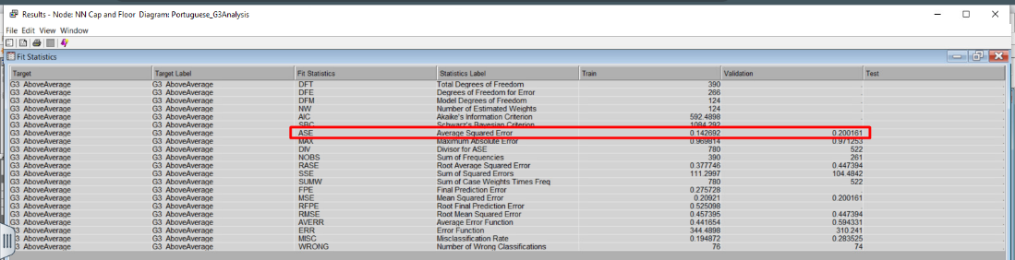

## Transform Neural Network

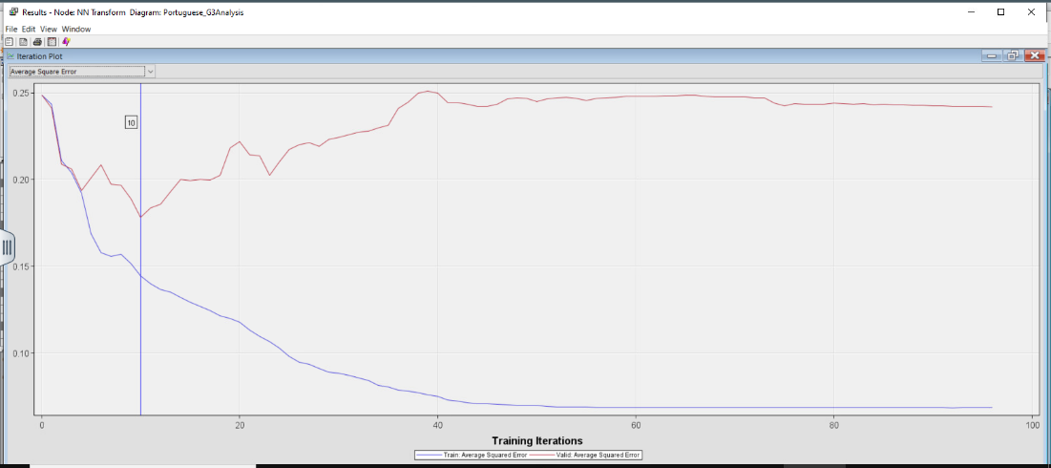The next Neural Network is the Transform Neural Network connected to the Transform node. This Neural Network shows the number of training iterations the model made and as the properties of the Neural Network are set to a maximum of 100, the Transform Neural Network converges and gets the optimal iterations at 10. This model has an Average Squared Error of **0.178348**. The diagrams below illustrate the results.

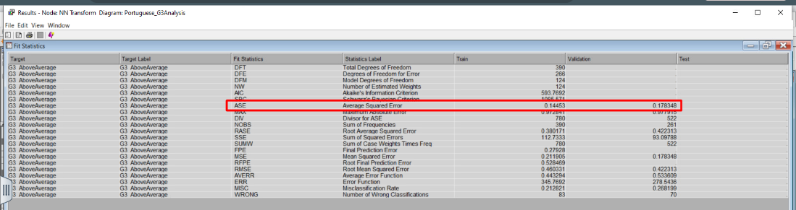

## Stepwise Regression Neural Network

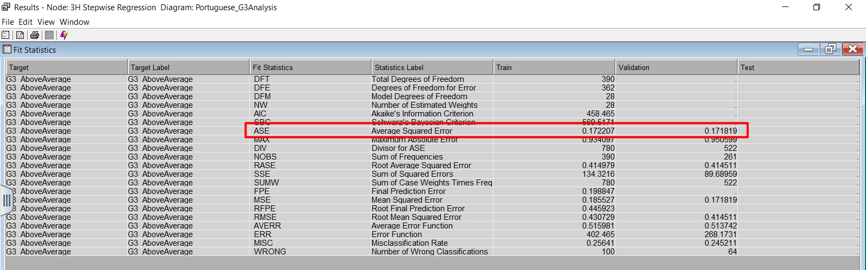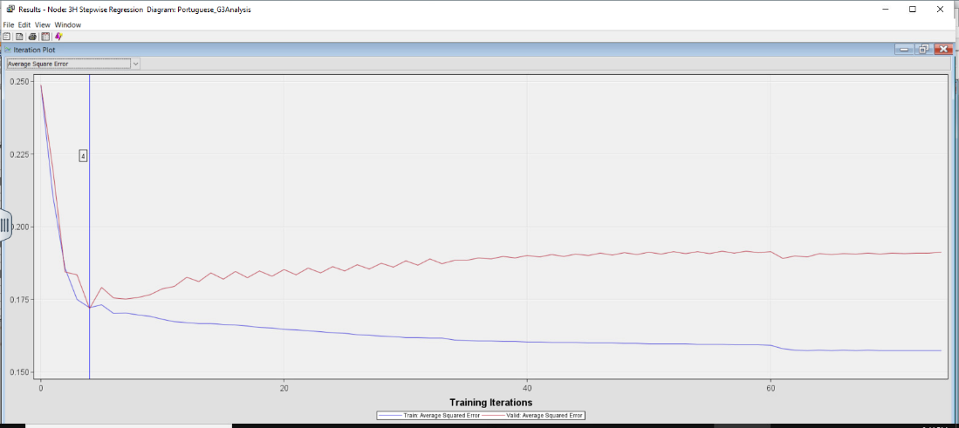The next Neural Network is the Stepwise Regression Neural Network connected to the Stepwise Regression node. This Neural Network shows the number of training iterations the model made and as the properties of the Neural Network are set to a maximum of 100, the Stepwise Regression Neural Network converges and gets the optimal iterations at 4. This model has an Average Squared Error of **0.171819**. The figures below depict the iteration plot and fit statistics of the model.

## Forward Regression Neural Network

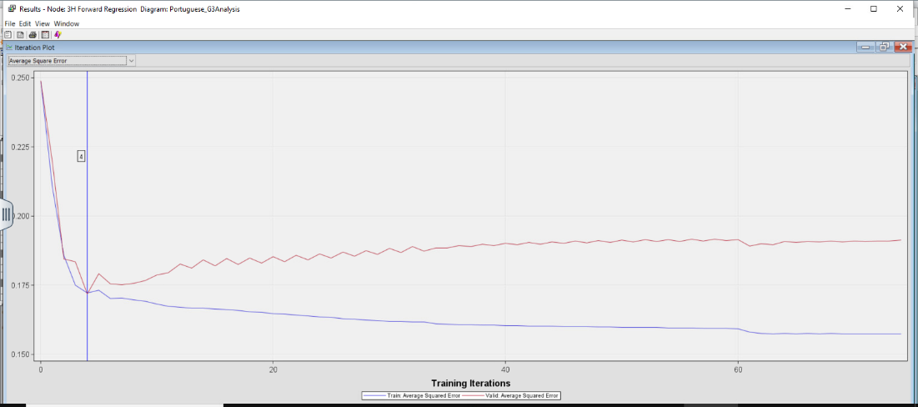The next Neural Network is the Forward Regression Neural Network connected to the Forward Regression node. This Neural Network shows the number of training iterations the model made and as the properties of the Neural Network are set to a maximum of 100, the Forward Regression Neural Network converges and gets the optimal iterations at 4. This model has an Average Squared Error of **0.171819**. The results of this model are depicted below.

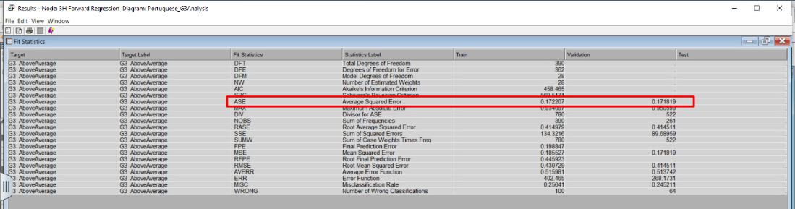

## Backward Regression Neural Network

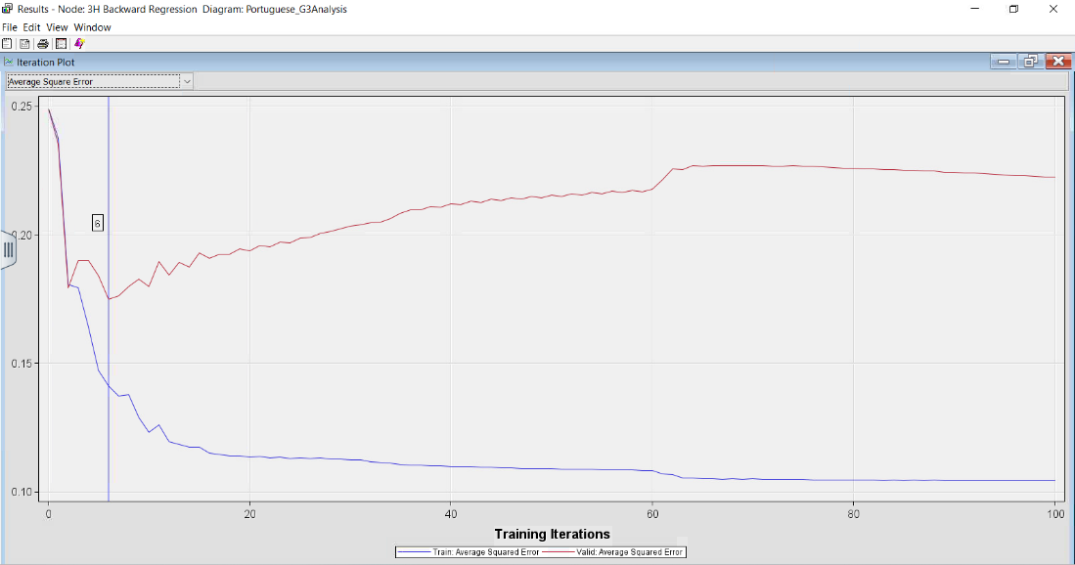The next Neural Network is the Backward Regression Neural Network connected to the Backward Regression node. This Neural Network shows the number of training iterations the model made and as the properties of the Neural Network are set to a maximum of 100 iterations and in this model the Backward Regression Neural Network gets the optimal iterations at 6. This model has an Average Squared Error of **0.174979**. The results of this model are provided in the figures below.

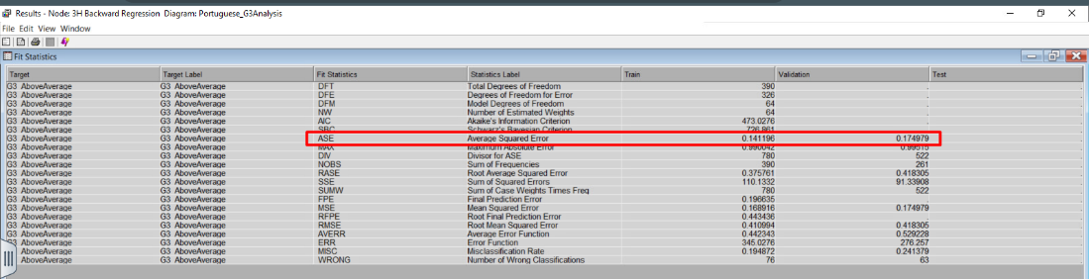

## Full Regression Neural Network

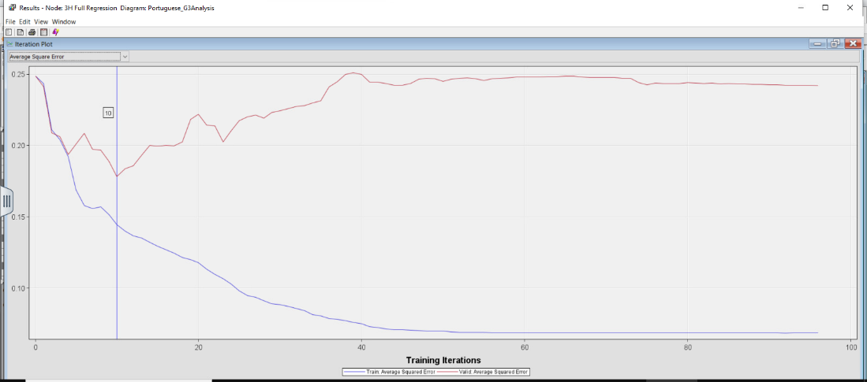The next Neural Network is the Full Regression Neural Network connected to the Full Regression node. This Neural Network shows the number of training iterations the model made and as the properties of the Neural Network are set to a maximum of 100, the Full Regression Neural Network converges and gets the optimal iterations at 10. This model has an Average Squared Error of **0.178348**. The results of this model are provided in the illustrations below.

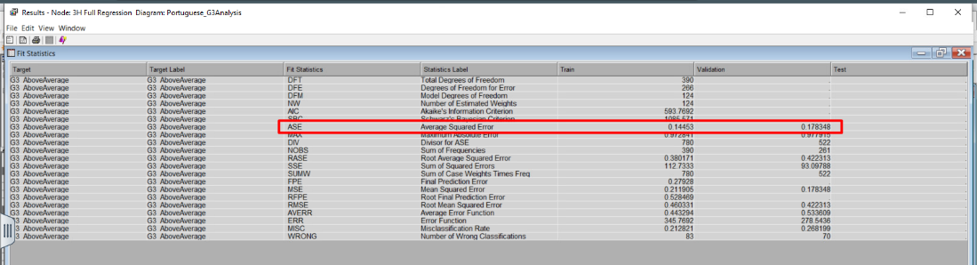

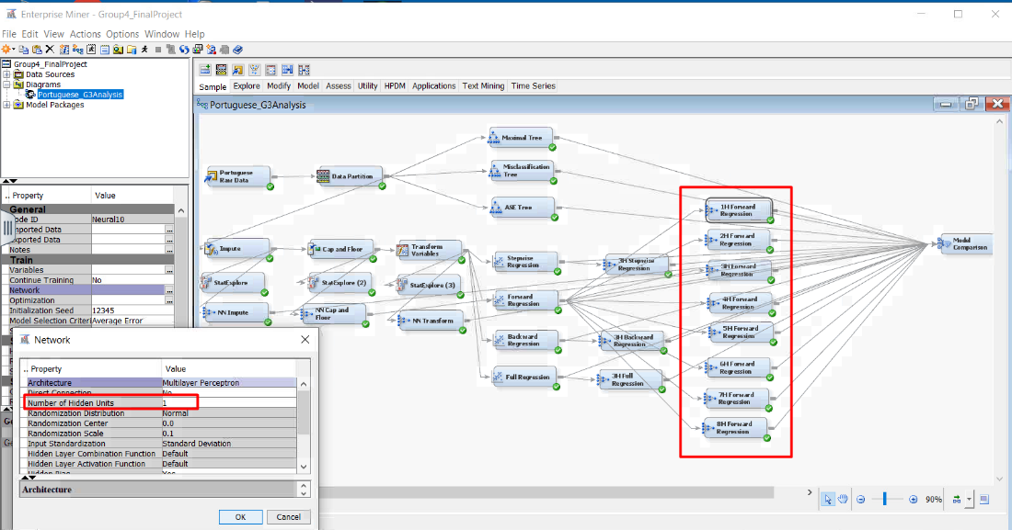Based on all the neural networks that have been explained above, the 3H Forward Regression Neural Network and the 3H Stepwise Regression Neural Network have the lowest ASE (0.171819) out of all the neural network models. Between these two models, while one is not better than the other, the Forward Regression Neural Network has been selected for the next step. To find the optimal Forward Regression Neural Network, the number of hidden units has been changed within the range of 1 to 8.

## 1H Forward Regression Neural Network

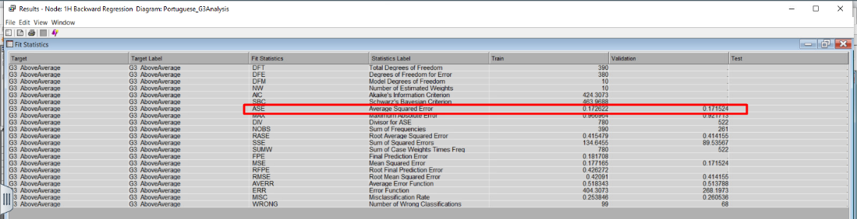

## 2H Forward Regression Neural Network

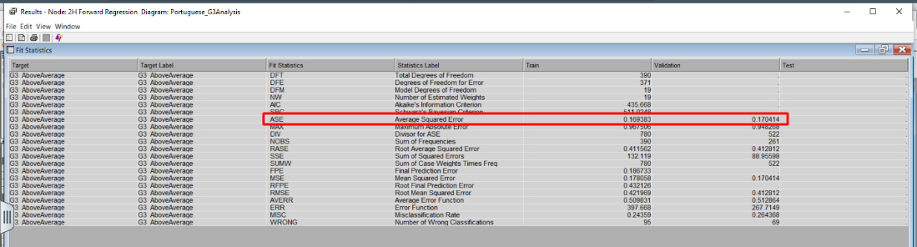

## 4H Forward Regression Neural Network

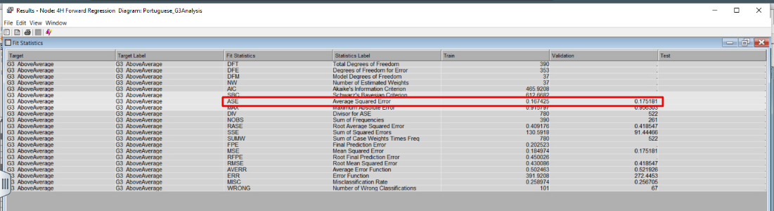

## Inserting image...5H Forward Regression Neural Network

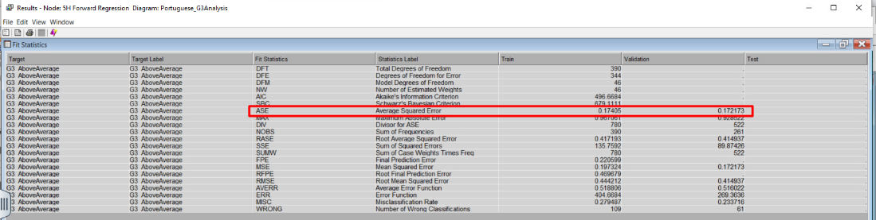

## 6H Forward Regression Neural Network

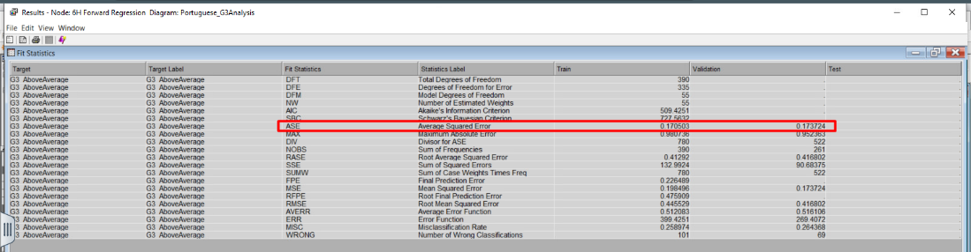

## Inserting image...7H Forward Regression Neural Network

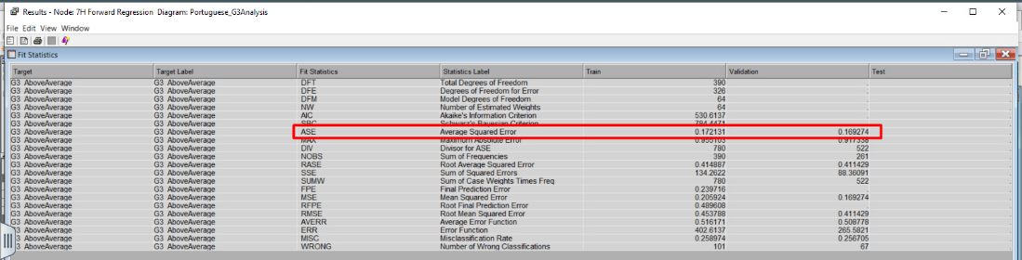

## 8H Forward Regression Network

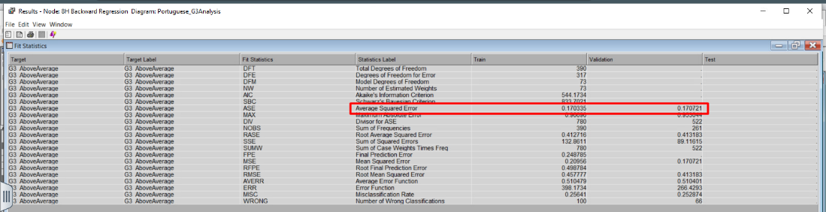

## Analysis of Neural Network

While Neural Network models are not subject to interpretation, the table below depicts which is the best model to use based on ASE values, the number of iterations, and convergence status of the created models. Looking at the data, the best neural network model happens to be **7H Forward Regression NN** with ASE of **0.169274** and 2 iterations. It is followed up by **2H Forward Regression** **NN** model with an ASE score of 0.170414. Although the 2H Forward Regression NN model has a greater number of iterations, it displayed convergence before reaching 100 iterations.

|  |  |  |  |
| --- | --- | --- | --- |
| **NN Model** | **ASE** | **Number of iterations** | **Convergence** |
| Neural Network Impute | 0.184225 | 11 | Yes |
| Neural Network Cap and Floor | 0.200161 | 9 | Yes |
| NN Transform | 0.178348 | 10 | Yes |
| 3H Stepwise NN | 0.171819 | 4 | Yes |
| 3H Forward NN | 0.171819 | 4 | Yes |
| 3H Backward NN | 0.174979 | 6 | No |
| 3H Full Regression NN | 0.178348 | 10 | Yes |
| 1H Forward Regression NN | 0.171524 | 7 | Yes |
| 2H Forward Regression | 0.170414 | 9 | Yes |
| 4H Forward Regression | 0.175181 | 4 | No |
| 5H Forward Regression NN | 0.172173 | 3 | No |
| 6H Forward Regression NN | 0.173724 | 3 | No |
| 7H Forward Regression NN | 0.169274 | 2 | No |
| 8H Forward Regression NN | 0.170721 | 3 | No |

# Model Comparison

In the final step, a model comparison node has been created and connected with every model node in the diagram. In the properties section, Selection Statistics has been changed to ROC and Selection Table to Validation. This step has been conducted to compare the ROC index of all the models and determine which one is the optimal model.

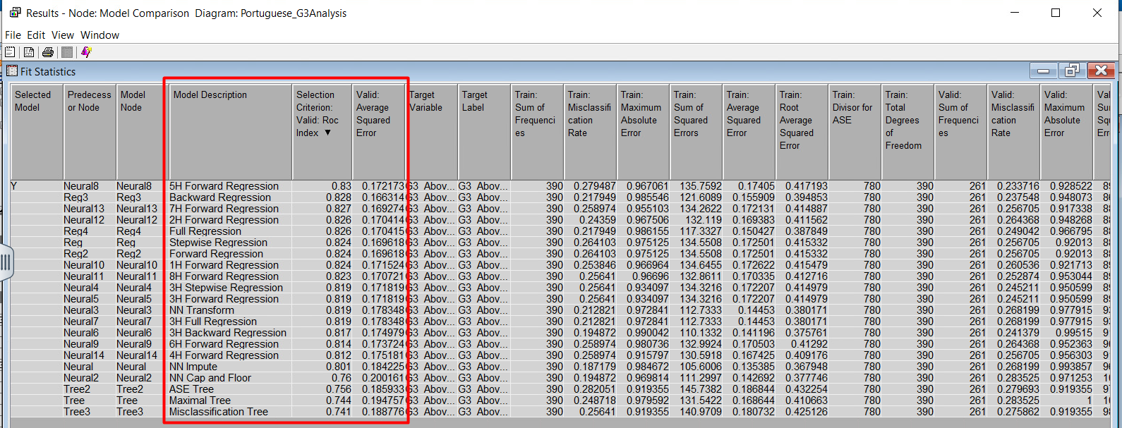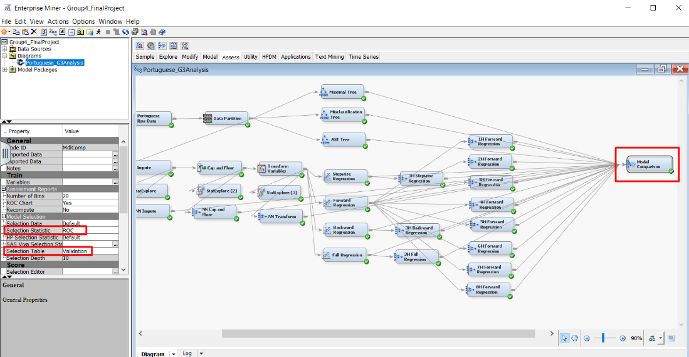

## Analysis of model comparison

Although the 7H Forward Regression NN is the best neural network model concerning the ASE value, the ROC index of **5H Forward Regression NN** is the best neural network model and the best model overall with a score of 0.83. While this is the optimal model at predicting success for students getting an above-average score for G3, this model cannot be interpreted.

The next best interpretable model is **Backward Regression** with a ROC index of 0.828, which is only 0.02 less than that 5H Forward Regression NN. Additionally, this model has the best ASE score (0.166314) among all the models.

Another notable result is the **ASE Tree**. Although the ASE tree is the best decision tree in terms of ASE value, its ROC index is the third lowest out of all the predictive models (0.756).

### Interpretation of Backward Regression Model

During the model analysis, a notable finding was that the backward regression method involved 23 steps, eliminating variables with higher Pr > ChiSq values. Upon completion, it revealed that variables with a Pr > ChiSq below 0.05 had the highest probability of success. The variables with the lowest Pr > ChiSq and the highest Wald Chi-Square were, in order of importance, the following:

1. *failures_past* with the No result*,* a Wald Chi-Square of 22.06 and a Pr > ChiSq of <0.0001.
2. *school* with a GP result, a Wald Chi-Square of 16.69 and a Pr > ChiSq of <0.0001.
3. *sex* with a F result, a Wald Chi-Square of 10.54 and a Pr > ChiSq of 0.0012.
4. *higher* with the No result, a Wald Chi-Square of 9.12 and a Pr > ChiSq of 0.0025.
5. *REP_absence* with a Wald Chi-Square of 8.84 and a Pr > ChiSq of 0.0030.
6. *activities* with a No result, a Wald Chi-Square of 6.12 and a Pr > ChiSq of 0.0133.
7. *Fedu* with a Wald Chi-Square of 3.97 and a Pr > ChiSq of 0.0464.

As for the odds ratio, the best variables for this model can be interpreted as follows in order of their impact on the target variable:

1. ***failures_past:***Students who have not failed in the past are 11.103 times more likely to score above-average grades in G3 than students who have failed in the past.
2. ***school*:** Students who go to GP school are 2.934 times more likely to score above-average grades in G3 than students who go to MS school.
3. ***sex*:** Students who are Female are 2.321 times more likely to score above-average grades in G3 than students who are Male.
4. ***higher:*** Students who do not want to pursue a higher education are 90.5% less likely to score above-average grades in G3 than students who want to pursue a higher education.
5. ***Rep_absence*:** For every unit increase in *Rep_absences*, there is a 9% decrease in the probability of scoring an above-average grade in G3. This indicates that as students' absences increase, the probability of scoring an above-average grade in G3 decreases.
6. ***activities*:** Students who do not perform any extracurricular activities are 46.2% less likely to score above-average grades in G3 than students who perform any extracurricular activities.

# Conclusion and Recommendations

Upon running each predictive model of decision trees, regressions and neural networks, along with the model comparison node, the optimal model has been identified in order to predict the students’ performance in the final period grade of the Portuguese subject. Additionally, the key variables that drive the final period grade above average have also been discovered.

Based on the findings, the following rank-ordered business recommendations can be made:

1. **Prioritize support for students with a history of academic failures:** Implement targeted interventions or support systems for students who have previously failed. These students are significantly less likely to score above average, indicating a need for tailored academic support or mentoring programs.
2. **Highlight the importance of school choice:** Emphasize the advantages of attending Gabriel Pereira over Mousinho da Silveira in terms of academic performance. Consider showcasing the positive outcomes associated with attending that school.
3. **Address gender disparities:** Develop initiatives to ensure equal opportunities for all genders in education. Provide additional support or programs specifically tailored to address any disparities that might affect male students' performance compared to female students.
4. **Promote higher education aspirations:** Encourage and support students' aspirations for higher education. Providing resources, guidance, and information about the benefits of pursuing higher education could positively impact their academic performance.
5. **Mitigate the impact of absences:** Implement strategies to reduce absenteeism among students. Addressing the issue of absenteeism could potentially improve students' likelihood of achieving above-average grades.
6. **Encourage extracurricular engagement:** Promote and facilitate extracurricular activities within the academic setting. Encouraging students to participate in extracurricular activities can potentially enhance their academic performance.

# References

Abu Bakar, N., Yusop, H., Ali, N.M., Abu Bakar, N.F. (2023). Determinants of Students’ Academic Performance in Higher Learning Institutions in Malaysia. International Journal of Academic Research in Business and Social Sciences, 13(2), 1496-1508. http://dx.doi.org/10.6007/IJARBSS/v13-i2/16250

Chauhan, A. (2022). *Student Performance: Predict student performance in secondary education (high school)*. Kaggle. https://www.kaggle.com/datasets/whenamancodes/student-performance

Regier, J. (2011). Why is Academic Success Important?. Saskatchewan School Boards Association. https://saskschoolboards.ca/wp-content/uploads/2015/08/2011SIAST.pdf

Tadese, M., Yeshaneh, A. & Mulu, G.B. (2022). Determinants of good academic performance among university students in Ethiopia: a cross-sectional study. BMC Medical Education, 22(395), 1-9. https://doi.org/10.1186/s12909-022-03461-0